8 How to Separate Two Vertices Stuck Together
10/26/2026
Let’s say you accidentally merged these two vertices together. One belongs to the outer rim of the ear, and one belongs to the body. How would you go about fixing this kind of thing.
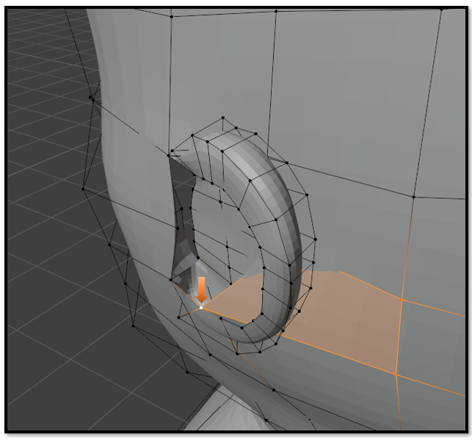
Well, Blender has a tool just for this. It is called Rip Region. You can find it on the left hand side of the view port. It is the last little icon
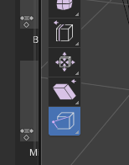
Just select that little merged vertex.
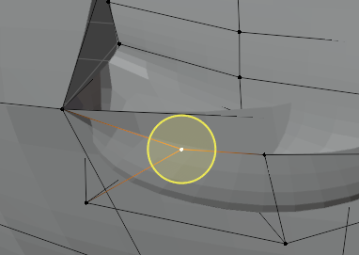

And Ripppppp… that thing apart.
Now those two things are separate. Cool!
